**Java Web开发**

**实验五**

**作业报告**

|  |  |
| --- | --- |
| 学 院 | 计算机 |
| 所在系 班 级 | 2017软件工程系10班 |
| 学 号 姓 名 | 13171224 陈煜晖 |
| 指 导 教 师 | 罗永升 |
| 完 成 时 间 | 2019年4月7 |

# 实验题目

实验内容：

练习老师在理论课上演示的购物车实例，理解购物功能如何实现，理解如何利用session对象保存购物信息，如何设计封装数据类。（请参考“第四章会话管理课上的购物车实例代码.docx”文档）；

# 分析与设计

关键源码（部分）

Chart.java

**ublic** **class** Chart {

String productID;

String productName;

**float** productPrice;

**int** shopNum;

**public** **Chart**(String id,String name, **double** price){

**this**.productID=id;

**this**.productName=name;

**this**.productPrice=(**float**)price;

**this**.shopNum=0;

}

**public** **void** **setShopNum**(**int** shopNum) {

**this**.shopNum = shopNum;

}

**public** String **getProductID**(){

**return** productID;

}

**public** **void** **setProductID**(String productID) {

**this**.productID = productID;

}

**public** String **getProductName**(){

**return** productName;

}

**public** **void** **setProductName**(String productName) {

**this**.productName = productName;

}

**public** **float** **getProductPrice**(){

**return** productPrice;

}

**public** **void** **setProductPrice**(**float** productPrice) {

**this**.productPrice = productPrice;

}

**public** **int** **getShopNum**() {

**return** shopNum;

}

**public** **void** **setShopNum**(){

**this**.shopNum=shopNum;

}

}

Foodcount.java

**public** **void** **doGet**(HttpServletRequest request, HttpServletResponse response)

**throws** ServletException, IOException {

doPost(request,response);

}

/**

* The doPost method of the servlet. <br>

*

* This method is called when a form has its tag value method equals to post.

*

* **@param** request the request send by the client to the server

* **@param** response the response send by the server to the client

* **@throws** ServletException if an error occurred

* **@throws** IOException if an error occurred

*/

**public** **void** **doPost**(HttpServletRequest request, HttpServletResponse response)

**throws** ServletException, IOException {

response.setContentType("text/html;charset=utf-8");

HttpSession session=request.getSession();

request.setCharacterEncoding("utf-8");

String id, name="";

**float** price=0, totalPrice=0, num=0;

Chart[] chartS=(Chart[])session.getAttribute("chart");

String prods[]=request.getParameterValues("choice");

**if**(prods!=**null**)

{

**for**(**int** k=0; k<prods.length;k++)

{

id=prods[k];

**for** (**int** i=0;i<chartS.length;i++){

**if**(id.equals(chartS[i].getProductID())){

chartS[i].setShopNum(chartS[i].getShopNum()+1);

**break**;

}

}

}

}

}

ShopLogin.java

**public** **void** **doGet**(HttpServletRequest request, HttpServletResponse response)

**throws** ServletException, IOException {

doPost(request,response);

}

/**

* The doPost method of the servlet. <br>

*

* This method is called when a form has its tag value method equals to post.

*

* **@param** request the request send by the client to the server

* **@param** response the response send by the server to the client

* **@throws** ServletException if an error occurred

* **@throws** IOException if an error occurred

*/

**public** **void** **doPost**(HttpServletRequest request, HttpServletResponse response)

**throws** ServletException, IOException {

request.setCharacterEncoding("utf-8");

HttpSession session=request.getSession();

String name=request.getParameter("name");

**if**(name==**null**)

{

name="";

response.sendRedirect("main.jsp");

}

**else**{

session.setAttribute("customerName", name);

Chart[] chart=initChart();

session.setAttribute("chart", chart);

response.sendRedirect("food.jsp");

}

}

/**

* Initialization of the servlet. <br>

*

* **@throws** ServletException if an error occurs

*/

**public** Chart[] **initChart**(){

Chart[] charts=**new** Chart[4];

charts[0]=**new** Chart("0001","nike球衣",667.93);

charts[1]=**new** Chart("0002","立顿奶茶",23.10);

charts[2]=**new** Chart("0003","豆奶",18.00);

charts[3]=**new** Chart("0004","可口可乐",6.60);

**return** charts;

}

}

main.jsp

<%@page import="javax.servlet.http.HttpSession" %>

<HTML><BODY bgcolor=yellow><FONT Size=7>

<p>请输入用户名进行登录

<FORM action="shopLogin.view" method=post name=form>

<INPUT type="text" name="name">

<INPUT type="submit" value="提交" name=submit>

</FORM>

<%

String ID = (String)session.getId();

String name = (String)session.getAttribute("customerName");

**if** ((name!=**null**) &&(name.length()>0))

{

%> <p>登陆成功的ID号<%=ID %>

<P>session

<A HREF="food.jsp">欢迎选购商品</A>

<% }

%>

<FONT></BODY></HTML>

Food.jsp

<HTML><BODY bgcolor=cyan></FONT Size=5>

<%@ page language="java"import="ch5.Chart" %>

ID号<%= (String)session.getId()%><br>

<%

String name = (String)session.getAttribute("customerName");

Chart[] charts=(Chart[])session.getAttribute("chart");

%>

欢迎你，<%=name %>

<p>这里是食物柜台，请你选择购买的食物：

<FORM action="foodCount.do" method=post name=form></FORM>

<%

**if** (charts!=**null**){

**for** (Chart chart:charts){

%><br>

<input type="checkbox" name="choice" value=<%=chart.getProductID() %>>

<%=chart.getProductName() %>

<%=chart.getProductPrice() %>

<% }

%>

<INPUT TYPE="submit" value="提交" name="submit">

}

# 运行效果图

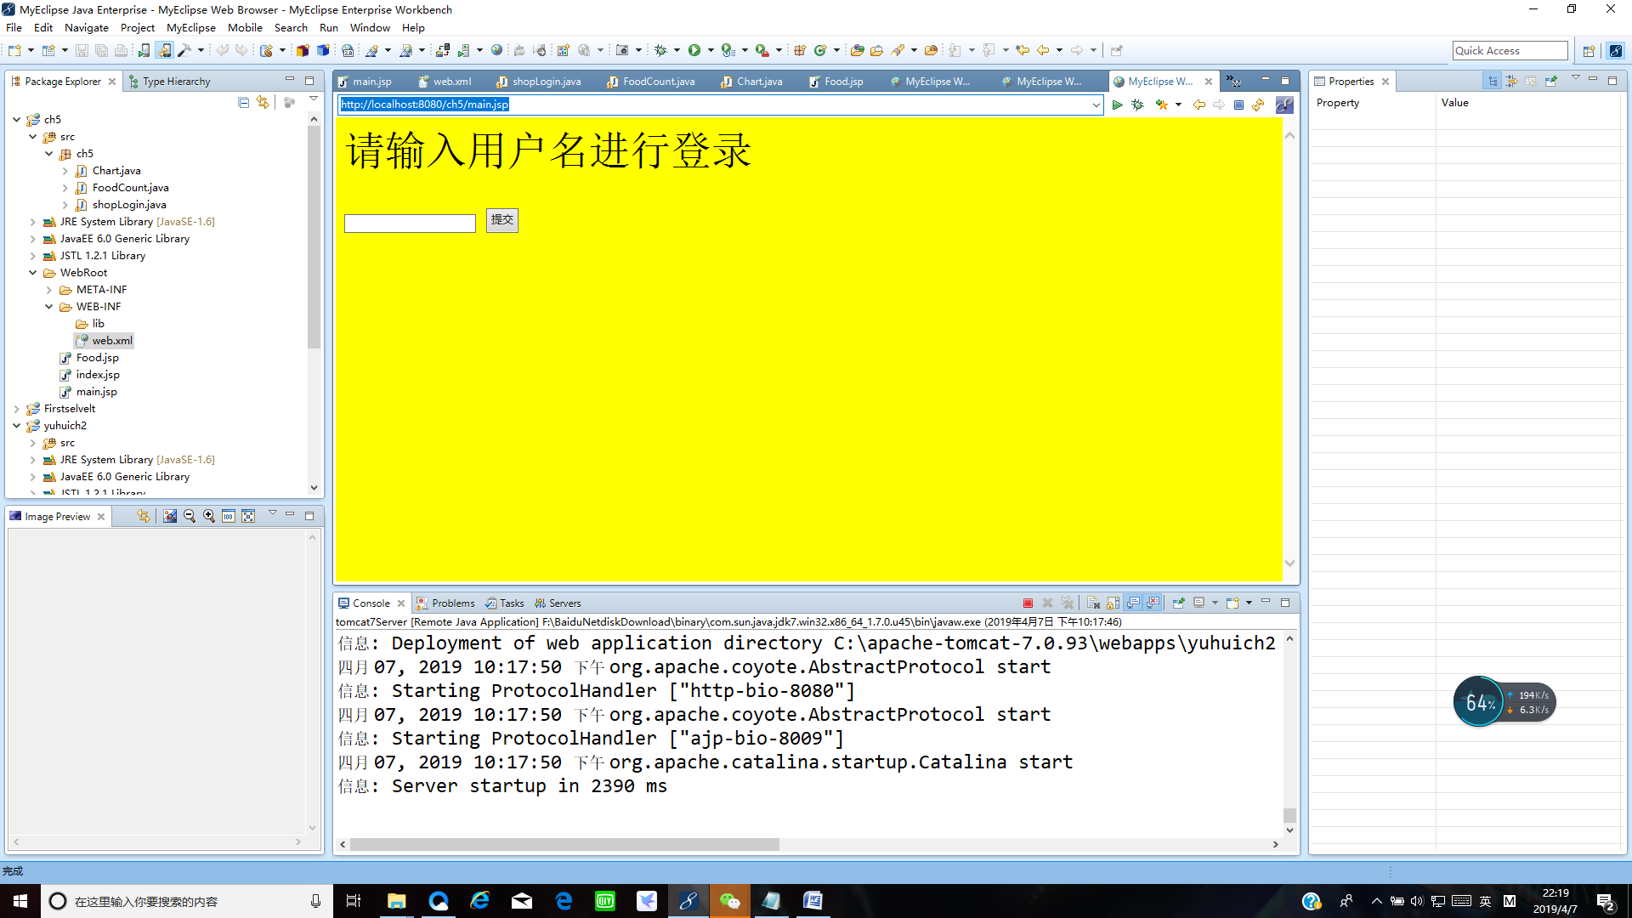

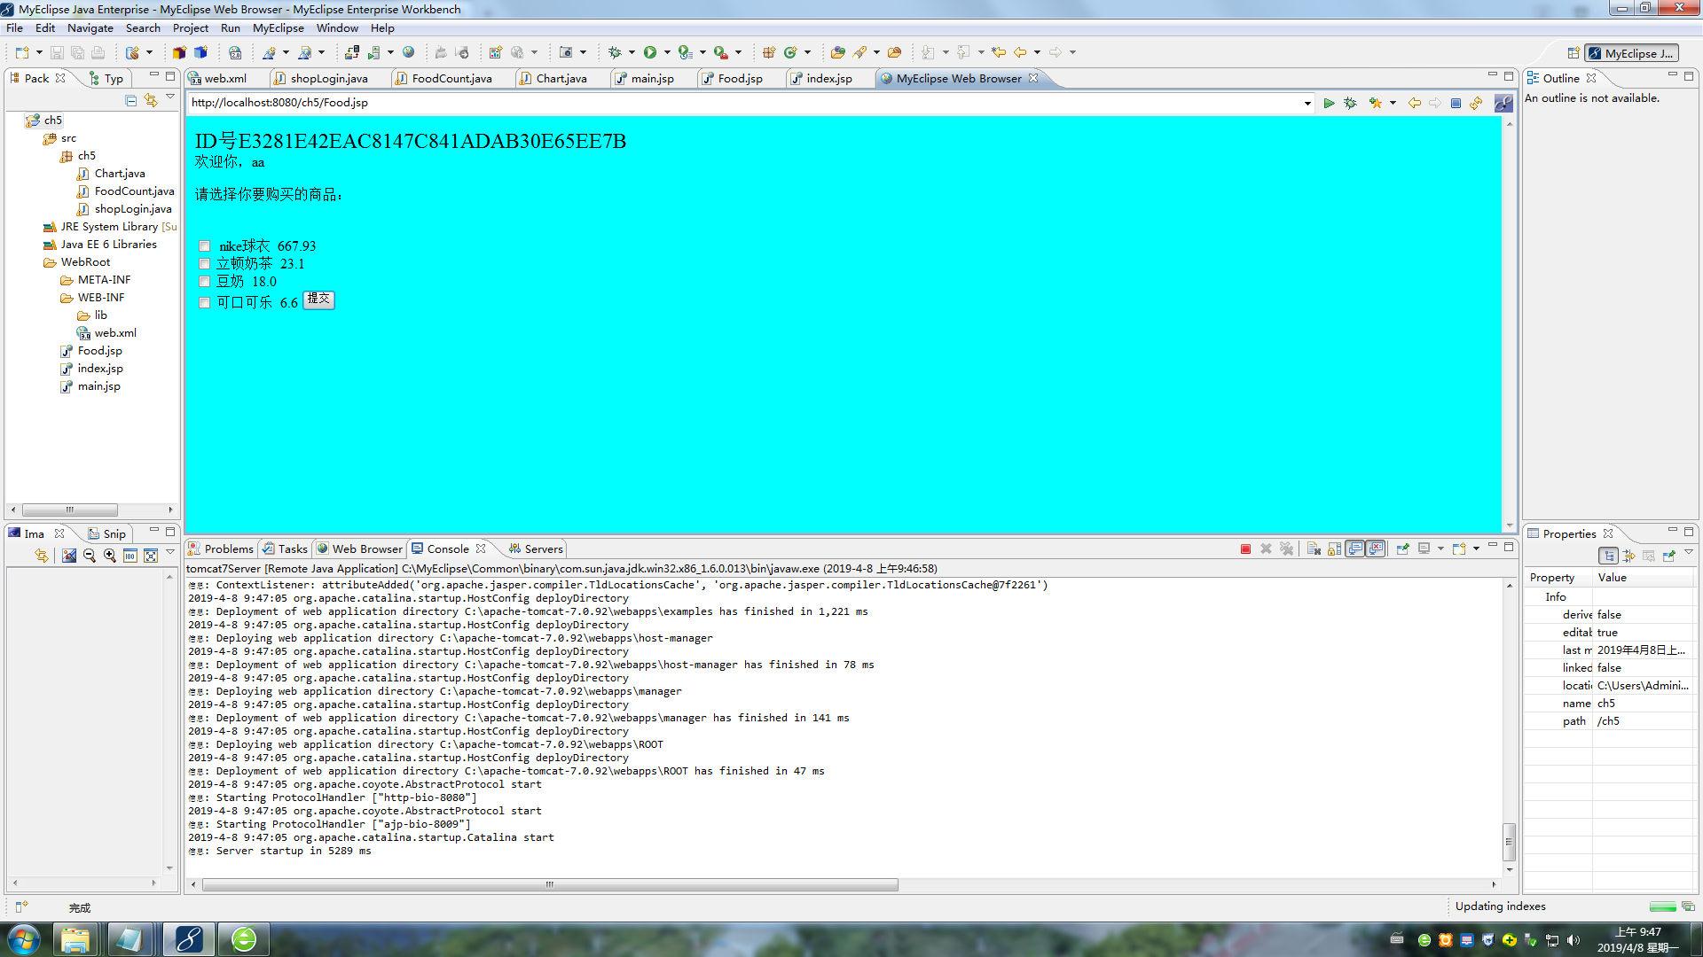

# 收获与问题

谈一谈你在本实验中所收获的内容及问题。